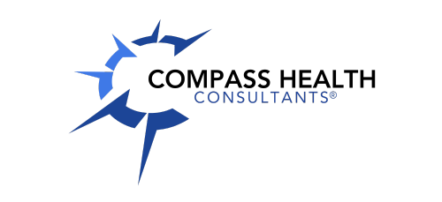

CHC Marketing Reimbursement

Compass Health Consultants will reimburse for certain marketing expenses. These expenses include,
- Marketing materials (required to include CHC logo and/or name)
- Advertising to bring in additional business (required to include CHC logo and/or name)
- Chamber of Commerce & BNI memberships
- Leads purchased outside of CHC
- Recruiting leads/programs outside of CHC (required to include the ad)
- Non-Resident licenses (only initial licenses, does not include renewals)
- Postage, mailers
- Business cards

CHC will reimburse 50% of the marketing expenses outlined above. We will deduct 50% from your marketing money and 50% will be paid out to you by payroll. Reimbursements will be paid out on the 23rd of each month. All reimbursements must be received by Billing by the end of the month (ex. If submitting March receipts, you must turn that in by March 31. CHC will not reimburse for past expenses. Please fill out the marketing reimbursement form and email the form and copies of all receipts to billing@chcquotes.com. Proof of payment is required for reimbursement.

*Please note…..Compass reserves the right to change or deny any requests*

